**Applications for IoT - Documentation**

Name : Kostis Thanos

Student number : 500739944

The languages I used for my web application in this project included javascript, php and html. After some research on the internet I decided to try to implement the Google API. I did this by obtaining the user’s position (by using the geolocation) and afterwards (containing longitude and latitude) storing it in a database (which is connected to in the php file datalogin). A piece of the code and the front end can be seen below.

*Insert location code*

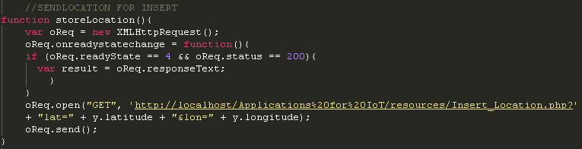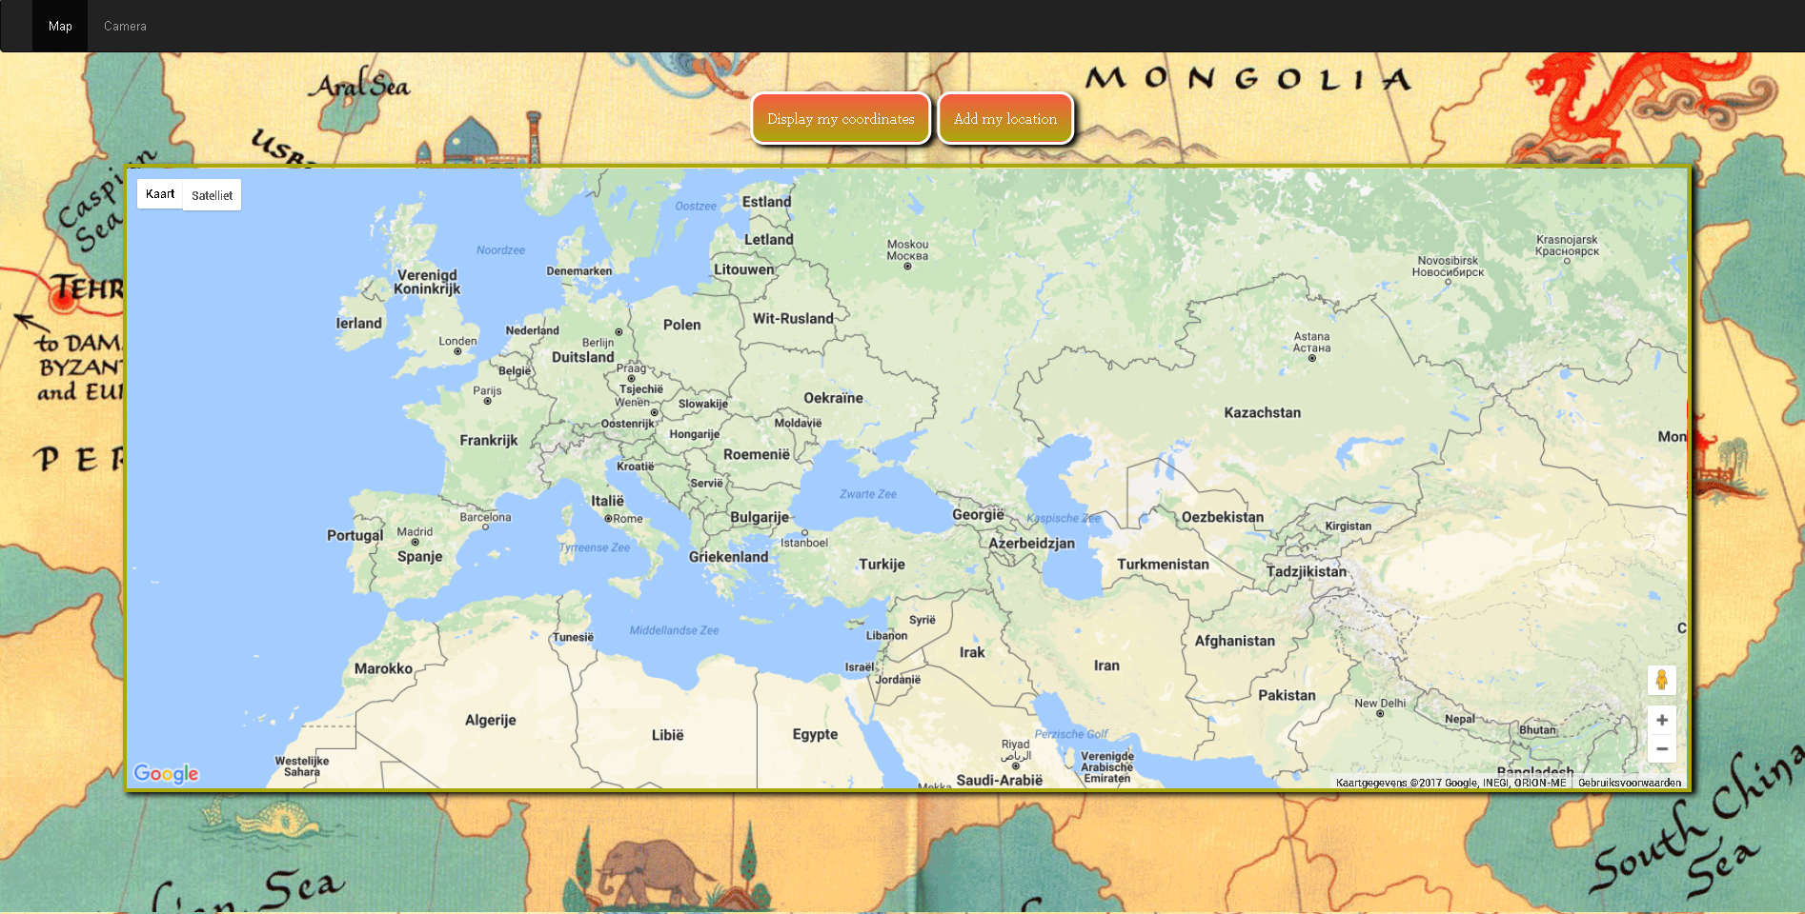

As can be seen in the code I use ajax in order to retrieve and send data to and from the server asynchronously. There is also an option to take one’s picture in the camera tab of the application.

Before using the webcam permission is asked from the user in order to gain access. Now the user can press the “Start Webcam” button in order to make a canvas appear with a camerastream, the bar on the bottom displays the amount of time the webcam is streaming.

after which the user is able to take a snapshot by pressing the “Take Snapshot” button. The webcam stream can then be stopped by pressing the “Stop Webcam” button. The snapshot can also be downloaded (by using the toDataURL) by pressing the “Download” option which will open a new screen.

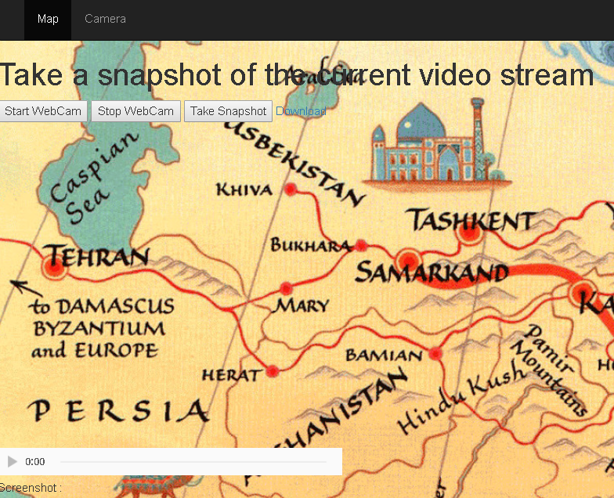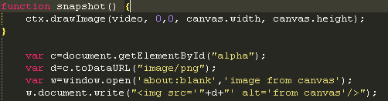

*Snapshot function code*

The information is stored to the database by using mysql queries. I have also used a css file in order to dictate the layout of the web application.

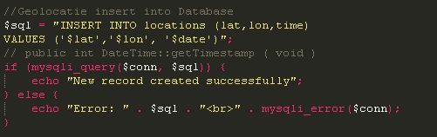

*Mysql code*